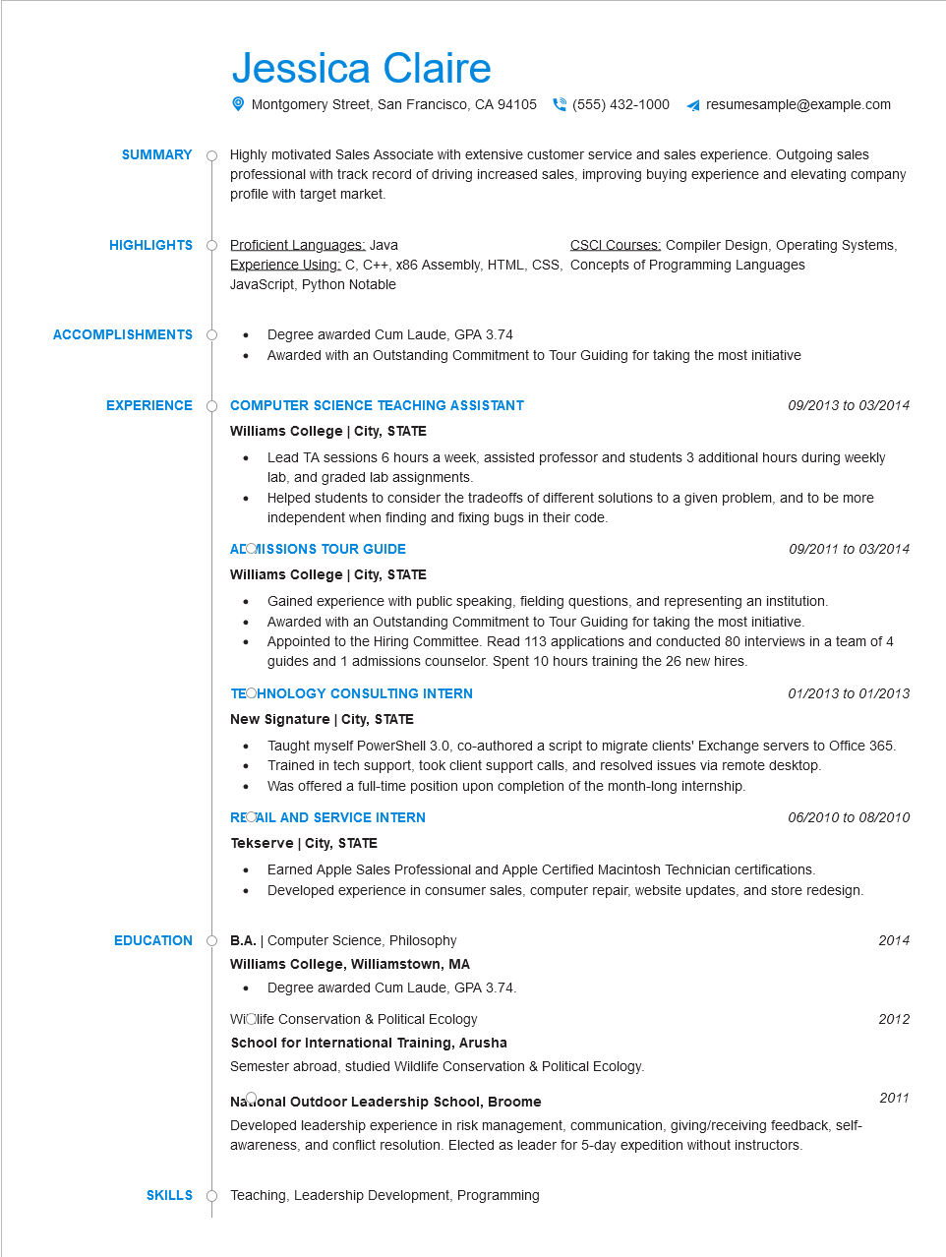
SUMMARY
Jessica Claire
Montgomery Street, San Francisco, CA 94105 (555) 432-1000
resumesample@example.com
Highly motivated Sales Associate with extensive customer service and sales experience. Outgoing sales professional with track record of driving increased sales, improving buying experience and elevating company profile with target market.
HIGHLIGHTS
Proficient Languages: Java
ACCOMPLISHMENTS
CSCI Courses: Compiler Design, Operating Systems,
Experience Using: C, C++, x86 Assembly, HTML, CSS, Concepts of Programming Languages JavaScript, Python Notable
Degree awarded Cum Laude, GPA 3.74
· Awarded with an Outstanding Commitment to Tour Guiding for taking the most initiative
EXPERIENCE
COMPUTER SCIENCE TEACHING ASSISTANT Williams College | City, STATE
EDUCATION
09/2013 to 03/2014
• Lead TA sessions 6 hours a week, assisted professor and students 3 additional hours during weekly lab, and graded lab assignments.
• Helped students to consider the tradeoffs of different solutions to a given problem, and to be more independent when finding and fixing bugs in their code.
ACOMISSIONS TOUR GUIDE
Williams College | City, STATE
09/2011 to 03/2014
Gained experience with public speaking, fielding questions, and representing an institution. Awarded with an Outstanding Commitment to Tour Guiding for taking the most initiative. Appointed to the Hiring Committee. Read 113 applications and conducted 80 interviews in a team of 4 guides and 1 admissions counselor. Spent 10 hours training the 26 new hires.
TECHNOLOGY CONSULTING INTERN
New Signature | City, STATE
01/2013 to 01/2013
Taught myself PowerShell 3.0, co-authored a script to migrate clients' Exchange servers to Office 365.
• Trained in tech support, took client support calls, and resolved issues via remote desktop. Was offered a full-time position upon completion of the month-long internship.
RECAIL AND SERVICE INTERN
Tekserve | City, STATE
•
06/2010 to 08/2010
Earned Apple Sales Professional and Apple Certified Macintosh Technician certifications. Developed experience in consumer sales, computer repair, website updates, and store redesign.
B.A. | Computer Science, Philosophy
Williams College, Williamstown, MA
Degree awarded Cum Laude, GPA 3.74.
2014
Widlife Conservation & Political Ecology
2012
School for International Training, Arusha
Semester abroad, studied Wildlife Conservation & Political Ecology.
Nasonal Outdoor Leadership School, Broome
2011
Developed leadership experience in risk management, communication, giving/receiving feedback, self- awareness, and conflict resolution. Elected as leader for 5-day expedition without instructors.
SKILLS Teaching, Leadership Development, Programming

